NOW 6 YEARS OLD !

S K A T
NO TOLLS!
Established 1995
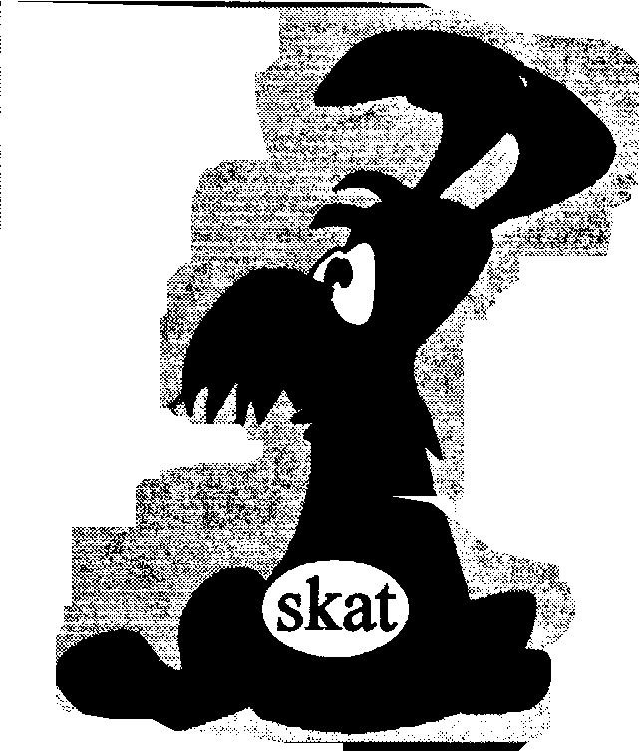
Skye & Kyle Against Tolls
SKAT NEWS
Autumn 2001

SSK

WHAT SARAH BOYACK DOESN'T KNOW

Cost of buy out - "Don't Know" Cost of VAT - "Don't Know" Cost to public bodies - "Don't Know"

SKAT has recently been corresponding with Sarah Boyack, the Scottish Executive's Transport Minister, in an attempt to get accurate figures on the costs of subsidising the Skye Bridge Private Finance Initiative. In a reply to our letter to the Minister, the Transport Department admits that they don't know how much it would cost to buy out the toll concession, only that "the costs would undoubtedly be substantial" - but then the cost of the subsidy is "substantial"! They also admit that at present they have "no intention of ending the Concession prematurely". So no matter what the subsidy costs, they don't want to know how much Taxpayers' money would be saved by buying out the Concession.
On the cost of VAT, which will inevitably be enforced as a European Directive, the Transport Department has told us that "the Scottish Executive is working with other Whitehall Departments" to consider "the possible costs involved". So, as yet, they don't know, despite Treasury Ministers having given a commitment that the cost will be absorbed. And VAT only applies because this is a privately operated bridge; if publicly operated, as other toll bridges in Scotland are, there would be no VAT to pay.
The Department also doesn't know how much is spent by public bodies (a figure not included in the Scottish Transport Department figures below) whose staff have to cross the Bridge in the course of their work and whose tolls are paid out of public money. We have one figure of £48,000 p.a. paid by Highland Council for its Education Department alone !
Ron's figures were just about right.

SKAT wanted confirmation that the figures which our ex-Chairman, Ron Shapland MBE, B.Sc., FICFor, spent a considerable time calculating , were correct. Readers will remember in our "Pre-Election Special" issue of SKAT NEWS that Ron's figures, based on an estimated income to the Skye Bridge Company of £4million a year, with inflation running at 2.5% p.a. and with the tolls frozen at 1999 prices, showed the cost of the subsidy would rise by £100,000 each year. So far, we have received from the Scottish Executive figures for the subsidy as follows;-
1998} £1.35 million over 2 years =
1999} £675,000 (p.a. average)
2000 £820,000 (calendar year)
2001 £1million (fiscal year, estimated cost, from Jim Wallace)
2002 £1.1million (fiscal year, estimated cost from Jim Wallace)

The trouble is, these figures will inevitably rise year on year, a)because the Government is absorbing the cost of the 'frozen' toll charges, and the Government/Taxpayer pays the balance of 'real charges' to Skye Bridge Ltd./Bank of America, and b) VAT will be introduced on the tolls, as Europe is now insisting with threats of penalties. On the basis of an income from tolls of £4million, with VAT at 17.5% this will add another £700,000 to £820,000 subsidy above. So, SKAT has 3 questions for Sarah Boyack:-
- Since our figures appear to be correct and taxpayers' money could be saved with a 'buy-out',
will the Government disregard this and continue to subsidise this private enterprise?
2. Will your Department provide accurate yearly figures of the cost to the taxpayer of this PFI ?
3. Will your Department provide a true estimate of the cost of buying out the Concession to show what savings of taxpayers money could be made ?
(Cont. on p3)

"Lochalsh Monster" is a composite by Andy, Jo & Milly

SKAT's own Gothic tale of haunting terror and fear from the windswept mountains and shores of the Misty Isle !!

The Lochalsh Monster

The story so far:-
The Wicked Witch from the South had released a great, hungry Monster on the people of Skye. The Monster was now full grown and was gobbling up all the resources of the Skye peasants who had now lost all their customers. Attempts to starve the Monster into submission had failed and it now demanded greater and greater amounts of dosh since it considered a whole loaf of bread today to be a mere slice of a 1991 Kingsmills. Promises from Donnie the Song that his master, Tony the Smile, would rid the people of the crushing burden of feeding the Monster had proved false and even Charlie of the Thousand Programmes had gone to foreign lands to seek fame and fortune and was now rarely seen in the vicinity of the Monster. John 008's clansmen, led by Jean of the Cèilidh, offered some hope for the Sgianathachs to get part of the Wicked Witch's magic power and make the Monster vanish, although Farquhar the Brave said he was still determined to fight on.
Now read on-
After the great clan battle of Wastemisters in 2001, it was soon learned that Tony the Smile had again defeated the Wicked Witch's clan and had total control of the magic power. John 008's clansmen had been greatly outnumbered in that foreign territory and could not hope to win the battle outright so they returned to the hills and glens to prepare for the next battle, this time on home ground and with better hopes of success. William the Vague had been supplanted by a look-alike, Iain Euro-Slayer, who also favoured Monsters so no change there. Nor had there been a reported sighting of Charlie of the Thousand Programmes for some considerable time.

Meanwhile in his cave on the shores of Loch Moglach, meditating on the terrible situation of the poor Skye people and the threat of the Monster, Farquhar the Brave noticed 12 ants busily gathering twigs and leaves for their nest. Admiring their co-operation and strategy of united effort, he had a sudden vision of how the Monster could be defeated. He resolved to find 12 strong men and true who would swear an oath never to rest until they had uncovered the secrets of the Monster's strange existence. What hidden power was protecting the creature ? How much was it costing Sarah the Cyclist to feed it and prevent it from attacking innocent Frequent Users ? Why were all the savings in the Monster's piggy bank being diverted to a foreign power across the water ? Was it true that the Monster had the secret of eternal life, due to a renegotiation clause in his birth certificate issued by the Wicked Witch ? Would the people of Skye have to feed the Monster for ever and ever ?
Farquhar the Brave would have to plan his attack with great care: the peasants themselves warned Farquhar the Brave that they could no longer challenge the Monster as it simply spat penalty points at their driving licences, rendering them useless. They told the story of how, last month, a MOD Scimitar Tank had bravely come face to face with the Monster but the Tank had finally been forced to give it alms of £5.70 to be allowed to pass. The Monster was fearless, they said. "How can such a creature survive in isolation?", they asked. "There must be some great hidden source of power shielding it" they concluded glumly. "It's all a great conspiracy to help it gobble up our fragile economy".
Farquhar listened to the troubles of the poor people with great sympathy. "There must be some way to defeat the Lochalsh Monster", he said resolutely. "If only I can get 12 knights of integrity and valour who will not flinch from the threats of excommunication from their clans for asking awkward questions".
Meantime, a small but determined band of warriors had been writing letters secreted inside poison darts which they fired at Sarah the Cyclist challenging her to reveal the real cost of food parcels for the Monster. So far, Sarah the Cyclist's manservant had claimed they didn't know the total food bill, only the cost of subsidised snacks. The warriors talked of how, as the Monster had grown, - 6 years old this October - the same amount of food which filled its belly 6 years ago now only satisfied about half its appetite so it cost more and more food every year as it grew just to keep the Monster at bay. And now there was an added threat from another land to the east. They wanted the Monster to be given Valuable Additional Treats (VAT) so they could get a share of the spoils extorted from the peasants.
The band of warriors, therefore, had decided to seek the help of one of John 008's clan. This bold knight was not only brave, but clever with it. He knew how to do sums with money and the warriors believed he would know how to calculate how much Monsters cost to feed and, more importantly, how much it could cost to make them vanish since his clan were sworn to rid the nation of Profiteering Fleecers of Islands (PFIs) and Practisers of Profitable Pranks (PPPs) against which other bands of warriors were now marshalling their troops. The new knight's name was Andrew and since this was the name of their patron saint they considered this a good omen and they named him Andrew the Abacus. But would this knight be able to defeat the Monster and save the people of Skye?
POP ! !

Support from Across Scotland
* * * * *

While SKAT continues to fight the injustice to the local community of the tolls on the Skye Road Bridge, support comes from another organisation with a growing concern about the effects on the wider community of the PFI/PPPs. The Association of Scottish Community Councils has seen the disastrous effects of the tolls on the Skye economy and are watching warily the results of PPP projects in other areas of public services across the country.
I raised the issue of the Skye tolls at the National Conference of the ASCC in Dumfries on the 9th of June this year. Conference, and by a massive majority (78 councils for 3 against, and only 7 abstentions) passed my resolution calling on ASCC Executive to press the Scottish Executive for a full Public Enquiry into the Skye Bridge Toll Scheme.
"communities everywhere are becoming aware of threats from PPP projects in their own vital public services and are highly suspicious of them."
Why should a national group like ASCC be concerned? It is 6 years since the Skye Road Bridge opened. It is a relatively small project (£12.5m), and it is in a very remote and somewhat isolated area of Scotland. The considerable support gained for this motion, from all corners of Scotland, representing urban and rural communities, prosperous and less prosperous areas, industrial, and agricultural areas, needs some explanation.
Of course if we wanted to flatter ourselves, we in SKAT could claim that it was all down to our effective campaigning, or good presentation of the issue, but there is more to it than that. The truth is that communities everywhere are becoming aware of threats from PPP projects in their own vital public services and are highly suspicious of them. They can see that the PPP game is great for politicians, local or national, because they can announce new facilities, without having to identify the resources to provide them.
It is reminiscent of the introduction of hire-purchase - or 'HP' - in working class communities in the early 1950’s; after the long period of deprivation during the war and its immediate aftermath, people could now get their hands on consumer goods even if they had little or no savings. Getting things "on the HP" or the “never-never” could give the false impression that you never had to pay for these goods. The PPPs are the “never-never” of present day politicians, except of course that in their case it is true - they don't have to pay, they just sign up on our behalf and we, our children, and our grandchildren will ultimately have to pay through the nose.
What people see in the Skye Bridge scheme is that a small £12.5m investment will cost well over £100m to repay, and indeed costs considerably more each month in revenue than it would do to raise a loan at high interest rates and pay it off. The other aspect of such public/private deals is that they are blanketed in secrecy. Every aspect of the deal is covered in “commercial confidentiality” which covers a multitude of sins, and a wagon-load of civil service incompetence, and is impenetrable even by the Criminal Courts.

SKAT Treasurer, Andy Anderson, is also the West Highland Representative to the Association of Scottish Community Councils (ASCC).

* * * * * * * * * * * * * * * * * * * * * * * * * * * * * * * * * * * * * * * * * * *

(cont. from p1)
So now, the Taxpayer will subsidise this Private Finance Initiative in three ways -
- by absorbing the cost of the subsidised books of tickets
- by absorbing the cost of the annual price index increase
- by absorbing the cost of VAT.
This might be an appropriate point at which to cast your mind back to 1989 when the then Highland Regional Council was told that Skye could not have a publicly funded road bridge because the Government couldn't afford it. The only option, they were informed, was to accept a Private Finance Initiative road bridge with tolls. The same road bridge could have been built as a publicly funded project for £12 ½ million. Now that we have the PFI version, the Government/Taxpayer will have subsidised this Private Finance Initiative to the tune of £35 million over 16 years. And that doesn't include the direct cost to the motorist who, having already paid his road tax and fuel tax, has to shell out money to Bank of America every time he drives across that mile of trunk road .
www.skat.org.uk
Skat Office Bearers

SECRETARY – FUTURE SKAT MEETINGS -
Jo Scott Moncrieff - 01476 236 217 All on Saturdays at 6.00 p.m.
E-mail; jo@her-computer.com

13th October The Cabin, Portree
VICE-CONVENOR –
Amelia Simonini – 01471 844 314 27th October The Cabin, Portree
E-mail; amelia.skye@lineone.net
10th November The Cabin, Portree
TREASURER –
Andy Anderson – 01470 542 365 24th November An Acarsaid, Broadford
E-mail: andy_a_2000@yahoo.co.uk
8th December The Cabin, Portree

FULL DEBATE ON SKYE BRIDGE IN SCOTTISH PARLIAMENT ?

The MSP for Ross, Skye & Inverness West, John Farquhar Munro, has petitioned to present a motion for a debate on the whole issue of the setting up of the Skye Road Bridge and it tolls. We are hopeful that John Farquhar will get the 12 signatures from other MSPs which are necessary to present the motion. We are also hopeful that such a debate would bring into
the open just what kind of deal was stitched up between the then Tory Government in Westminster and Miller Group (whose shares were later bought out by Bank of America). There have been many questions asked and not answered about just how much Bank of America is guaranteed to make from motorists and taxpayers out of this no-risk private venture.

PLEASE NOTE: SKAT, Skye & Kyle Against Tolls, is the original SKAT continuing to function according to its original constitution of Jan. 1997 and has no connection with any other group of similar name.

GIVE US YOUR VIEWS
Many SKAT supporters can't manage to come to our meetings, some because of distance from Skye (this is truly an international organisation with members in Europe, USA, Canada and Australia as well as many parts of the British Isles). Nevertheless, we would like to hear from you and to have your views on our campaign - or perhaps you have a local PFI/PPP story to tell. We are interested to have your views so please let us know.
*********************
As always, running a campaign costs money and while we no longer have heavy legal costs we still have to meet bills for advertisements, stationery, postage, phone calls, attendances at meetings. It all adds up. So if you would like to show your support for out attempts to get the Government to remove the tolls from the Skye Road Bridge and give the people of Skye a fair deal, please use the tear-off slip below to send a contribution. It will be gratefully received.
Please return this slip to;- Andy Anderson, SKAT Treasurer, 22 Earlish, Uig, Isle of Skye
----------------------------------------------------------------------------------------------------------------------------------

I enclose a cheque no………../postal order no………….
as contribution to SKAT funds.

